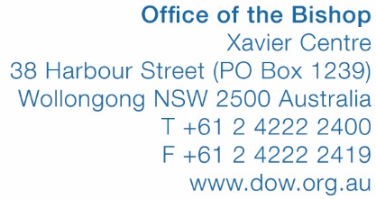

REGISTER OF VISITING PRIESTS
ON THE AUSTRALIAN CATHOLIC MINISTRY REGISTER

SITE BEING VISITED IN  DIOCESE OF WOLLONGONG | The Hermitage  843 Old South Road, Mittagong NSW 2575
DATE OF ARRIVAL
(Example: Saturday 10 September 2016)

DATE OF DEPARTURE
(Example: Sunday 11 September 2016)

NAME OF PRIEST
FROM (DIOCESE)

CURRENT RELIGIOUS CONGREGATION
AND/OR PARISH
(Example: SJ, Mt Druitt)

ACMR NUMBER

WORKING WITH CHILDREN CHECK NUMBER
DATE OF BIRTH
PURPOSE OF VISIT | Ministry to visiting group  Other: ……………………………….
NAME OF VISITING GROUP
SIGNATURE OF PRIEST

PLEASE EITHER:
- PRINT, COMPLETE AND MAIL FORM TO MARY HISCOX AT THE BISHOP’S OFFICE AT THE ABOVE ADDRESS, OR
- COMPLETE FORM ELECTRONCIALLY AND EMAIL TO mary.hiscox@dow.org.au

WW:mbh:8005Wollongong (as amended for The Hermitage – March 2017)
25 January 2017

