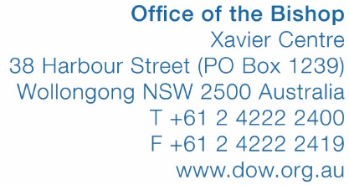

REGISTER OF VISITING PRIESTS
WITH MINISTRY CARD
FOR MINISTRY IN THE DIOCESE OF WOLLONGONG

SITE BEING VISITED IN  DIOCESE OF WOLLONGONG | The Hermitage  843 Old South Road, Mittagong NSW 2575
DATE OF ARRIVAL
(Example: Saturday 10 September 2016)

DATE OF DEPARTURE
(Example: Sunday 11 September 2016)

NAME OF PRIEST
FROM (DIOCESE) | Broken Bay  Parramatta  Sydney
CURRENT RELIGIOUS CONGREGATION AND/OR PARISH
(Example: SJ, Mt Druitt)

MINISTRY CARD NUMBER

PURPOSE OF VISIT | Ministry to visiting group  Other: ……………………………….
NAME OF VISITING GROUP
SIGNATURE OF PRIEST

PLEASE EITHER:
- PRINT, COMPLETE AND MAIL FORM TO MARY HISCOX AT THE BISHOP’S OFFICE AT THE ABOVE ADDRESS, OR
- COMPLETE FORM ELECTRONCIALLY AND EMAIL TO mary.hiscox@dow.org.au

WW:mbh:8005Wollongong (as amended for The Hermitage – March 2017)
25 January 2017

